Anzhelika Bondarenko
Ukraina, Krzywy Róg

Topicality of dichotomous approach in professional education of future music teachers in higher education establishments of Ukraine
The modern transformation in an arts education of Ukraine take place considering the ideas and concepts put forward by the international organizations, including the International Standards Department, UNICEF, UNESCO. The scientific thought of teachers dealing with research work is aimed at finding the ways of ensuring the effectiveness of the academic process in higher pedagogical establishments. The changing of the art education orientation from the formation of a personality to the development strategy requires from the music theory and practice to focus on the readiness of the teaching staff of higher education establishments (further HEE) to perform the identified tasks. The quality of academic achievements for the students-musicians depends on the effectiveness of the learning process, the formation of the structure of knowledge, the established harmonious relationship.
The main contradiction that prompted us to try eliminating it within our research is the discrepancy between the desire to achieve the harmony of the learning process in HEE and the inability by reason of some general understanding of the essence of this process, the insufficient focus of the specific pedagogical conditions, the reality, pedagogical situations.
The distinguished contradictions comprise the content of the problem examined by us, the essence of which is to determine the topicality of the dichotomous approach in the professional education of future music teachers in HEE of Ukraine.
Analysis of research and publications. The question of socialization as the inclusion of an individual into a society was studied in the works of N. Abdyukova, I. Kon, D. Feldstein et al. Considering the social nature of an individual, which corresponds to social activity, such scholars as H. Arsentyeva, B. Hrudynin, T. Malkovska, Sh. Nadirashvili, L. Serebryakov, V. Ternopilska et al. relied on the fact that "man is directly a natural being and is endowed with the natural, vital forces, being an active natural being" [4, p. 188]. The researchers defined the essence of the social activity of a man, the qualitative and quantitative characteristics. The attempts to investigate the characteristics of the social activity of a personality were made by such researchers as O. Golovakha, M. Kahan, O. Kyrychuk, Ya. Kolomynskyi, B. Lomov, T. Malkovska, N. Panina, O. Petrovskiy and pointed out that the communication process was the product of interaction of external and internal factors. T. Malkovska considering the social activity of an individual defines it as an activity that "creates the directives of personal and social relations" [3, p. 21].
Purpose of this article is to prove the topicality of the dichotomous approach in the professional education of future music teachers in higher education establishments of Ukraine on the basis of the theoretical analysis and generalization of the own teaching experience in the presentation of the conductor’s and choral subjects in HEE.
The task of the article is to determine the kinds of dichotomies detected in the academic process based on the understanding of the characteristic features of the professional education of students-musicians.
The obtained results. In the course of research of the necessity for the introduction of the dichotomous approach for the professional education of future music teachers, we consider the academic process in HEE as the one that predetermines the coexistence of such objects as a student and a social environment of HEE. During the communicative interactions a person will be acquainted with a definite social environment, determine its characteristics, the compliance with the standards, the level of significance and the importance of his(her) own for other entities of a specific social environment.
This differential way of knowing predetermines the dichotomous separation. The concept of dichotomy (dicha into two parts, tome – separate into two parts from the Greek) appears as a dual nature [6]. We believe that the dichotomy appears as a process of natural separation of the generic concept, which in our case is presented as a social forganization of the academic process in HEE into two mutually exclusive opposing specific concepts such as a student and a social environment of HEE. This mutual exclusiveness is in determining each other by quality, parts, goals, principles, etc. However, the distinguished concepts do not destroy the existing capacity of the phenomena which they reflect. The basis of this process is a difference in nature of the characteristic features of the types distinguished by us that is manifested by the absence in one of them and the presence in the other. At the same time they do not interfere each other by its capacity. Other words, one of the types by its presence does not interfere with the independent existence of the other. Following the considerations, we note that a dichotomous separation is manifested in the academic process in different ways, namely as bipolarity, symmetry, ambivalence, antinomy, antonomy.
In the course of study of the dichotomous separation in the process of the professional education of future teachers, we will consider bipolarity as a dichotomy type. The concept of bipolarity has the Latin prefix bi meaning “double structure” of the social organization of the academic process in HEE maintaining itself as the only reality fact in which two different phenomena coexist and unable to interchange or exist separately. So, a student’s personality and the social environment of HEE as the two specific concepts in the course of interaction during the academic process are forming the third integrated organization "communicative relations." It reflects their interaction in the educational and cognitive activity as the qualitative and more efficient one. That is, bipolarity predetermines the differentiation in the integration of the specified differentiated parts which preserve their ability for the independent functioning.
Taking this into account, we will consider the interaction of the social environment of HEE and an individual in the process of professional development reflecting such type of dichotomy as symmetry. The concept of symmetry is of Greek origin, and reflects the phenomenon proportional to the reality organization. Thus, the certain subjects of academic process identified by us existing independently are identical in features, such as: a part of a society; have responsibilities and rights; perform the actions aimed at achieving results of the academic process. The unity and interaction of these entities contribute to the balance and harmonize the created communicative relations. This necessitates their coexistence in the course of communicative interaction, where each object reflects itself in another. The determined balance predetermines the substantial significance of each of the object, defining the dimension of the internal structure of the certain generic concept [6].
Further, there is a necessary in the consideration of certain objects reflecting the following type of dichotomy - ambivalence. This requires the special consideration of certain objects of a society for determining their opposite sides which appears in the mutually exclusive definitions and characteristics. With an integral consideration of the social environment of HEE as an entity, it should be noted the possibility of creating the conditions for the creative development of a personality. However, when considering a student as a separate entity of an academic process, it turns out that on the one hand, he or she appears to be a self-sufficient personality, on the other hand, this isolation makes the level of his (her) cognitive abilities lower. That means that these objects tend to complementarity and mutual enrichment, that is proved by the essence of a notion of ambivalence (from lat. ambo - both, valentia - force), which appears in distinguishing a significance, strength of both objects. Ambivalence in the process of comparing of polar properties is presented as a manifestation of opposite qualities of certain objects.
The above mentioned information enables the consideration of these objects in the interaction showing such type of dichotomy as antonymy. This type is related to the notion of antonyms (from anti ... and Greek.onyma - name), expressing the words of opposite meaning [5, p. 65]. It should be noted that antonymy is expressed by the differences of outer organization of the social environment of HEE where distinguishing of the central subject is the starting point that affects the whole system of the academic activity.
Further studies of the necessity of the professional growth of future music teachers based on the dichotomous approach needs to consider such dichotomy type as antinomy, which is expressed in the interaction process of the defined objects. The concept of antinomy (from the Greek. antinomia - a contradiction in the law) is presented as a conflict between two judgments which are equally logically proven [5, p. 64]. As an expression of understanding of functioning the certain objects we use a circle. "The circle is a synthesis of the biggest opposites. It combines the concentric and eccentric in a single form and balance " [2, p. 34 - 46]. So, to put a society schematically where two such objects freely coexist (Figure 1.3), we determine the presence of a certain space between them. We consider this space as an educational and creative ane, enabling the mobility of the interaction process for the defined objects.

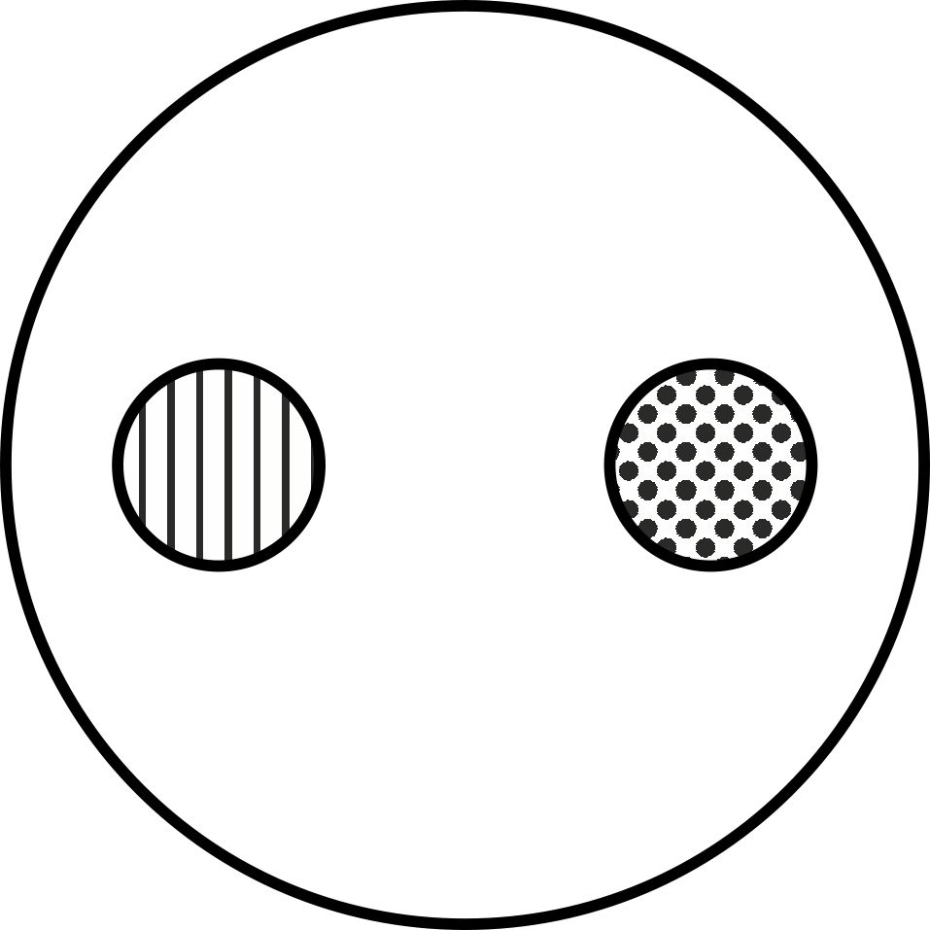
Fig.1.3

However, if we will examine this process of coexistence of the distinguished in the society objects as two self-sufficient flexible pedagogical phenomena, the necessary raises to determine them as the creators of educational and creative space that exhibit the ability to accumulate, making adjustments and implementing certain changes in the educational process (Fig.1.4). Hereby, the determined certain interacted objects are encounted creating an entity, but still there is a possibility of their separate existence. That is, antinomy is manifested in a certain contradiction defined by us between two definite provisions where everyone appears as a proven and therefore a true one.

Fig.1.4

Thus, we have identified a number of pedagogical dichotomies associated with opposite phenomena of reality which coexist and develop in the pair unity, and one of them can be understood only through the second one. The understanding of the essence of the processes occurring in the educational environment promotes the development of the ability of students to the creative interaction aimed at the performance of acquisition of the professional skills. Relying on this, the we can conclude that this dichotomous approach to musical and pedagogical education for future teachers can promote the harmonization process, improve its quality in order to ensure the competitiveness of the graduates on the international labor market.
The research does not cover all aspects of the subject, so to study the influence of the generic identity on the academic activity outcome of students-musicians is in future prospects.
Summary. For music pedagogical education the issue of the quality of an educational environment for higher education establishment (further HEE) has always been the focus for researchers. There fore, there is a necessary for the development of the pedagogical thought in the countries of the European Union, considering the state of affairs in Ukraine. The course of the academic process for students and the implementation of the humanitarian principles stipulate the essential functioning of HEE. These two components specify the quality level for functioning higher education establishments. The researchers consider it differently, from the conditions of the social environment and the quality of education to the issue of satisfaction of students demands. The great importance is understanding of the contradictions arisen from the process of the problem analysis. There is also the need to take into account the desire of students for self-expression in the course of academic process by means of the creative interaction with other participants of the process. The involving of future music teachers in the creative presentations requiring their creative self-expression plays an important role in the process of their training. For this purpose the HEE teachers use the works of music arts that contribute to solving the above-mentioned problems which arise not only in acquiring and improving students professional knowledge and skills, but also promoting the development of their communicative skills. In our research we also considered the needs of students for the creative process of their professional development. Young people are seeking their own way, which they will go in the future. The main purpose of the professional education of future teachers is obtaining of professional skills. The important factor in implementing the dichotomous approach to the process of training future music teachers is understanding of this process as a unique one, which implies the coexistence of such objects as a student and a social environment of HEE. Such a differential way of academic activity predetermines the dichotomous distribution in the lerning process. In order to optimize the ecademic environment, it is necessary to study the types of dichotomy, namely bipolarity, symmetry, ambipolarity, antonymy, antinomy. It should be noted that understanding of the essence of the social environment in the higher education establishment contributes to the quality of professional education for the students. The implementation of the dichotomous approach improves the efficiency of the academic process for the HEE future teachers. It also facilitates the achievement of harmony in a definite social environment. Based on the concept of social nature of man as the basis for the music pedagogical education, this article confirms the topicality of the dichotomous approach for the professional education of future teachers in the higher education establishment.
Key words: arts education in Ukraine, future music teacher, dichotomous approach.
Streszczenie
Dla pedagogiki muzucznej od zawsze było istotne i baczną zwracała uwage na jakość środowiska nauczania studentów. Dlatego należy dopatrywać się rozwoju poglądów pedagogicznych w wybranych krajach Unii Europejskiej ze szczególnym uwzględnieniem sytuacji w Ukrainie. Przebieg procesu nauczania studentów oraz prowadzenie humanizmu stanowią istotę funkcjonowania skoły wyższej. Te dwa obszary wyznaczają i stanowią o jakości pracy uczelni akademickej. Jest ono rozumiane wieloroko, poczynając od warunków otoczenia i jakośći nauczania do zadowolenie potrzeb naukowych. Niebez znachenia dla jego rozumienia jest ustalenie antagonizmów. Niezbędnu jest uwzględnienie dążenie studentów do wewnetrznośći przez kreatywnu interakcji. Ważna rolę w nauczaniu przyszłych nauczycielej muzuki odgrywają załaszanie do wystąpienia, którzy wymagają kreatywnego wyrażenia samego siebie. Dla tego wykładowca szkoły wyższej załaczają dzieła sztuki jaki powinni realizować zadania wychowawcze oraz łaczyć nie tylko umiejętnośći a nawyki, ale rozszerzać je na postanowienie problemy współdziałania komunikatywnego. W dalszych rozważaniach pojawi się potrzeba studentów co jest tendencja do unikania konfliktów i do odczuwania własnej potrzebności w rozwoju kreatywnym. Młodzież szukająca własnych dróg, którymi podążać będzie w przyszłośći. Głownym celem nauczania zawodowego studentów jest rozwój kompetencij zawodowych. W tym procesu wprowadzenia podejśćie dychotomiczne do nauczania przysłych nauczycielej muzyki jest ważne są także rozumienie procesu nauczania studentów w szkole wyższej jak jedyny co przewidywaje współistnienie takich przedmiotów jak student a środowisko socjalne w szkole wyższej. Ten dyferencjalny sposób badania przewiadywaje rozdzielienie dychotomiczne w procesi nauczania studentów. Dla optymalizacji środowiska uczenia należy zwrócić uwagę na typy dychotomii: bipolarność, symetria, ambiwalentność, antonimia, antunomia. Należy tu podkreślić, co zrozumienie istotności procesów środowiska uczenia sprzyje podwyższeniju jakości nauczania zawodowego. Takie dychotomiczne podejście przyczynia się do efektywności procesu nauczania, który powinien zachodzić w szkole wyższej. Możemy mówić o możliwoszchi osiągnięcie harmonii w środowisku nauczania studentów. I właśnie wychodząc z koncepcji społecznej przyrody człowieka – fundamentu pedagogiki muzycznej – zostanie poniżej przedstawiona kwestia koniecznego wprowadzenia podejście dychotomicznego do procesu nauczania zawodowego przyszłych nauczycielej muzyki.
Słowa kluczowe: artystyczna oświata w Ukrainie, przysły nauczycieli muzyki, podejście dychotomiczne.
Bibliografia
- Doronina T. (2011), Theoretical and methodological basis of gender education and the education of youth, Kryvoy Rog.
- Vlasov V. 2004, New Encyclopedic Dictionary of Fine Arts, Moskow.
- Malkovskaya T., 1978, Social activity of pupils and the way of its formation, Moskow.
- Marx K. Engels F., 1979, Works, Moskow.
- Prohorov A. (ed.), 1981, Soviet Encyclopedic Dictionary, Moskow.
- Frolova I. (ed.), 1987, Philosophical Dictionary, Moskow.

